Portable ECG monitor

based on

Android and Internet of Things

Submitted in partial fulfillment of the requirements

of the degree of

Bachelor of Engineering

By

Sagar Samant (60002115080)

Dereyk Dsouza (60002128006)

Mohammed Husein Sabuwala (60002115077)

Mitali Salvi (60002115079)

Project guide

Prof. Mrunalini Ingle



Electronics and Telecommunication

Dwarakadas J Sanghvi College of Engineering

2015

**CERTIFICATE**

This is to certify that the project entitled **“ECG Monitor based on Android and Internet of Things”** is a bonafide work of **Sagar Samant (60002115080), Dereyk Dsouza (60002128006), Mohammed Husein Sabuwala (60002115077) and Mitali Salvi (60002115079)** submitted to the University of Mumbai in partial fulfillment of

the requirement for the award of the degree of **“Bachelor Of Engineering”** in **“Electronics and Telecommunication”**.

Guide External Guide

Prof. Mrunalini Ingle

Head of Department External Examiner

Dr. Amit Deshmukh

Principal

Dr. Hari Vasudevan

Project Report Approval for B. E.

This project report entitled (***Title***) by (***Authors Name***) is approved for the degree of ____________ (***Degree details***).

Examiners 1.--------------------------------------------

2.---------------------------------------------

Date:

Place:

**Index**

|  |  |  |
| --- | --- | --- |
| **Chpt. No.** | **Topic** | **Pg. No.** |
|  | **Abstract** |  |
| I | **Introduction** |  |
|  | Motivation and Background |  |
|  | Selection of the project |  |
|  | Objective |  |
|  | Engineering Objectives |  |
| II | **System Plan** |  |
| III | **Electrocardiogram** |  |
|  | First Attempt at ECG |  |
|  | Three Lead ECG |  |
| IV | **Arduino Components** |  |
|  | Arduino Duemilanove Atmega328 |  |
|  | Adafruit CC3000 wi-fi breakout board |  |
|  | HC-05 Bluetooth Module |  |
| V | **Android-open Source Operating System** |  |
|  | Amarino software toolkit |  |
|  | Sensorgraph |  |
| VI | **Interfacing of the System** |  |
|  | Arduino to computer |  |
|  | Arduino to Bluetooth |  |
|  | Arduino to CC3000 wi-fi breakout board |  |
|  | Complete interfacing block diagram |  |
| VII | **Simulation** |  |
|  | ECG |  |
|  | Selection of ECG electrodes |  |
|  | Observations |  |
| VIII | **Applications and Enhancements** |  |
|  | Advantages |  |
|  | Disadvantages |  |
|  | Applications |  |
|  | Future Scope |  |
| IX | **Conclusion** |  |
| X | **References** |  |

**ABSTRACT**

This ECG monitoring project has been chosen keeping one thing in mind which is the lack of availability of doctors and the lack of proper medical instruments required to diagnose a particular cardiac problem in rural areas. This system could be made to be dependent on a core device that is an android device with a portable hotspot facility and which is connected to the GSM data network.

When a patient in any rural area suffers from any cardiac problem, the first thing that is required is medical diagnosis which becomes difficult in the absence of a skilled professional doctor. At such a point, our portable device comes to rescue. With this device, parameters concerning the ECG of the patient could be wirelessly transmitted over an existing GSM (preferably Wi-Fi) network and be made available to professional doctors sitting at remote locations on an Internet of things based interface. This project could further be improved to transmit additional vital signs like blood glucose levels through simple interfaces.

Before we considered designing the project, we explored current market options available to solve similar problems. We came across with a similar design proposed by Bhabha Atomic Research Center (BARC) and our device is largely a simplified version of it using just 3 leads instead of the general 12 lead design. This was done to ensure user friendliness and to provide for a simpler design. We looked into the availability of 3 lead ECG devices. We found that the available devices required a graphics LCD for the ECG display and transmitting the ECG signal wirelessly was one thing that wasn’t accomplished. We eliminated the requirement of the graphics LCD using an Android phone as a monitor and accomplished the connectivity using a Wi-Fi module.

**CHAPTER-1**

INTRODUCTION



* 1. **MOTIVATION AND BACKGROUND**

As per the World Bank database of 2013[2] related to the percentage of rural population in every nation, India is amongst the top nations with 68% of its population living in the rural areas. As a result for the overall development of our nation, we need to concentrate on the betterment of the rural life. However, due to rising competition and inflation in our economy, the industries have a tendency to produce/manufacture goods which can only be afforded by the people who have enough money to buy a luxurious life for themselves, particularly people living in the metropolitan cities. In order to earn huge profits on production, the manufacturer turn a blind eye towards the existence of people in the villages of our nation.

However, as a first step to change this view, we have chosen this project so that we can be a helping hand for the underprivileged people of the remote areas of the nation in the developing field of the health industry. On the other hand, this project has a universal approach and application and can be even used in the urban areas as ambulance testing kit, or at home for regular tests and many other uses.

Urban population which forms only 32% of the Indian population, get the maximum share when it comes to having access to all the medical health facilities. People from the rural areas have access to only 1/3rd of the beds in a normal standard hospital in India.

Current projections from statistics suggest that India will have the largest cardiovascular disease burden in the world. One-fifths of the deaths in India are from coronary heart diseases. By the year 2020 it is estimated that cardiovascular diseases will account for 1/3rd of all deaths in the nation. Patients suffering from cardiovascular diseases of the age group of 25-49 are almost 25%, which is 10-15 years earlier than that in the west. There is an estimated 45 million patients of coronary artery disease in India [3].

An increasing number of young Indians are falling prey to coronary heart diseases. With millions hooked to a roller-coaster lifestyle, the future looks even grimmer. Hence this project is a forward step to preventing this and making the lives of the people of our nation safe and sound as we know ‘Prevention is better than cure’.

1. **SELECTION OF THE PROJECT**

We are well aware about the lack of health facilities in remote places of India, as well as the inability of doctors to give proper treatment at the right time due to lack of transportation and infrastructure, whereas in some places doctors are not even present and there is not a single dispensary/clinic for miles together. As a result of this, it is difficult to diagnose a particular health problem in such areas. This project uses an android based health monitoring system which has been selected by keeping in mind all of the above facts. This system is dependent on the core device that is an android smartphone with a basic Bluetooth connectivity and an external Wi-Fi connection.

Diagnosis is the first step when a patient is found suffering from a medical condition. In many cases, medical diagnosis is not possible due to unavailability of a trained medical professional or doctor. In such a case, our health monitoring system would come to rescue. The patient can test his ECG with our self-health monitoring system. The final ECG can be displayed on the android device on our application via the Bluetooth connection and also can be uploaded to a website using Wi-Fi connectivity and forwarded to the doctor in contact with the patient and then the patient can be guided by the doctor as to what should be done.

The selection of the project is also done on the basis of the compactness of the final prototype and portability on the patient’s part. The analog part of the project is made in such a way that all modules can also be attached easily and can be compressed easily in a small portable box. The entire project is powered on a few batteries thereby making the project power conservative.

1. **OBJECTIVE**

As mentioned earlier, the project aims at being used in the rural parts of the country which implies that the first and foremost objective of this project is to be ‘affordable’.

Also we have strived to make the project user-friendly and easy to use, as well as easy to carry around and hence one of the main objectives is portability and compactness capped with user-friendliness.

The main intention of the project is to be able to connect the doctors and the rural patients. In order to carry-out this task, we need an internet connectivity which can be provided by any 3G network on a smartphone or a Wi-Fi dongle.

Hence the primary objective is to successfully provide medical assistance and support to the no so developed rural population in order to make their lives less miserable in the health industry.

1. **ENGINEERING OBJECTIVES**

Along with making the project, we also did a little market research regarding finding related products in the health sector. While doing so, we came across many devices that had the same functions but had some disadvantages when compared to our project idea.

The common thing in all these products was that they had a display unit; it had a power supply unit and a sensor making the entire product bulky and not so easy to be portable. Also the extra units of LCD display and power supply unit were redundant and made the product costly. Keeping in mind all these facts we engineered the final layout of our project and planned to make it into a prototype which can be easily turned into a product at lower costs.

Another engineering task in our prototype was the accommodation of all the units in a single place and not to make it look too messy to be used by a normal person at times of difficulties in health monitoring. We knew that we need a display device, a power supply and a high processing unit in order to make the project run efficiently.

We concluded that an android phone or tablet has all these features apart from the power supply which can be provided by a rechargeable battery. Hence we decided to use it and design the other hardware around it effectively so that it can be easily interfaced with the smartphone later on.

**CHAPTER-2**

SYSTEM PLAN



* An android application will be made available to the user on which he can view his own ECG and diagnose the faults if possible.
* Using a Wi-Fi module, the same ECG signal has been made available wirelessly to the doctor on an Internet of Things based application.
* The Wi-Fi module can be configured to work with a Wi-Fi or use the smartphone’s Wi-Fi hotspot feature.
* Doctor’s can look at the waveform for the day once at a stretch (or real time) and diagnose the faults to recommend medicine.
* This can reduce the physical patient traffic on the doctor’s side

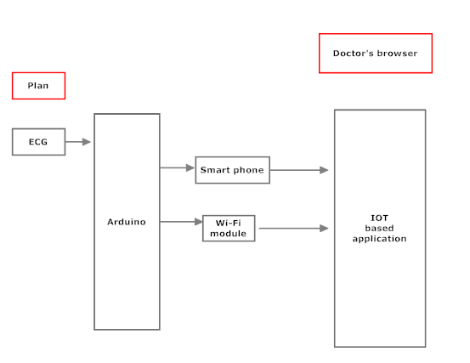

*Fig 2.1 System Plan*

* The processed ECG will be given to the analog input pins of the Arduino.
* This is directly transmitted via Bluetooth using serial interface.
* This data will be used to display the ECG on the Android based oscilloscope.
* This data is also sent simultaneously for display on an IOT based application using a Wi-Fi module.
* Thus data can be accessed by anyone using a phone or a desktop with the help of a URL.

**CHAPTER-3**

ELECTROCARDIOGRAM



The principle behind ECG measurement is that the beating of the heart generates an electric impulse that travels through the body, thus creating different electrical potentials in the body. The difference in electrical potential can then be measured using a differential amplifier. Below is a description of some of the ways we tried to measure the ECG signal. The electrical signal that initiates a heartbeat travels from left to right thus creating a difference in electrical potential.

**3.1 FIRST ATTEMPT AT ECG**

With a view to first looking at acquiring an ECG signal, we first explored the use of a simple op-amp circuitry. The op-amp is similar to that of a difference amplifier which amplifies the difference between signals at it’s two input terminals and hence the choice for acquiring the ECG signal. This simple circuit consisted of an operational amplifier, a 0.1 uF capacitor and two i/p resistors. The circuit LM324 as the operational amplifier.

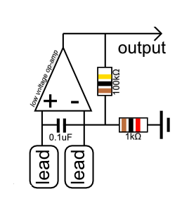

*Fig 3.1 A simple ECG acquisition circuit*

**How it works !**

The ECG signal is picked up using the positive terminal of the opamp. The negative terminal and the output have a feedback of 100k. The gain is set to 100 using this resistor. A capacitor of 0.1uF is connected between the two input terminals. Now we know that the reactance offered by the capacitor is given by :

Xc=1/2fC

Where Xc=reactance

f=frequency

C=capacitance

Now note that as the frequency increases, the capacitive reactance decreases. Thus the HF noise occuring at one terminal will be coupled to the other terminal and thus will be cancelled through the process of the difference.

Keeping this in mind, the output of the opamp was observed on a Digital Storage Oscilloscope. The output was nowhere close to an actual ECG signal. Conducting a little bit of research[1]  we came to know that the circuit proved to be inefficient due to the dominant 50Hz powerline induced noise. Through the same source, we also found out the ramge of ECG frequencies that were desired and the digital equivalent of the steps to be followed to obtain the signal.

**3.2 THE THREE LEAD ECG**

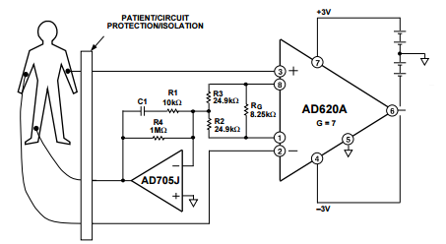

*Fig 3.2 Three lead ECG*

In order to get over with the problem of noise, a solution available is to introduce noise into the body so that the noise induced on the body would get cancelled out. The schematic for the same is as shown in Fig 3.2 . The schematic was as available from the data sheet of AD620 instrumentation amplifier[4]. We have replaced the AD620 in the above circuit with a better version i.e. AD622 instrumentation amplifier and the AD705 with a normal LM741 operational amplifier due to lack of availability.

The AD622 is a low cost, moderately accurate instrumentation amplifier in the traditional pin configuration that requires only one external resistor to set any gain between 2 and 1000. For a gain of 1, no external resistor is required. The AD622 is a complete difference or subtractor amplifier system that also provides superior linearity and common-mode rejection by incorporating precision laser-trimmed resistors. The AD622 replaces low cost, discrete, two or three op amp instrumentation amplifier designs and offers good commonmode rejection, superior linearity, temperature stability, reliability, power, and board area consumption. The low cost of the AD622 eliminates the need to design discrete instrumentation amplifiers to meet stringent cost targets. While providing a lower cost solution, it also provides performance and space improvements.[4]

The simple ECG circuit was unable to cancel out all the noise and give a recognizable ECG signal the reasons for which can be attributed to the lack of filters (because of which there wasn’t any arrangement to filter out the required frequencies in the 0.05Hz to 35 Hz band). Moreover ,the circuit had a single operational amplifier which could not offer a very high CMRR which resulted a low rejection of common mode signal on both the input pins. In short, the noise created a lot of problems and a lot of efforts had to taken to ensure that the noise would be filtered out. The schematic shown above only ensures that the common mode signal gets filtered out. It also has a driven right leg circuitry (RL-drive) which works as a common ground for the circuit and inverts unwanted noise picked up by the leads and sends it back into the patient to ensure that the noise gets cancelled. The circuit works by providing two input leads which are connected to the right hand and to the left hand. The third electrode is connected to the right leg. The electrical impulses generated by the heart are picked up by the electrodes and given to the input terminals of the instrumentation amplifier as shown above. The cables used in the path are shielded coaxial cables used to prevent EMI from external sources. The shield is grounded to completely drain the induced voltages and prevent the noise from corrupting our ECG signal flowing through the core. The AD622 provides a mere gain of 8 to avoid loading the next stage with the increased noise voltage levels generated if a high gain was used. The next stage involves using a low pass filter with a cutoff frequency of 35 Hz and a gain of 100. Thus the entire block diagram for ECG acquisition and processing is as below:

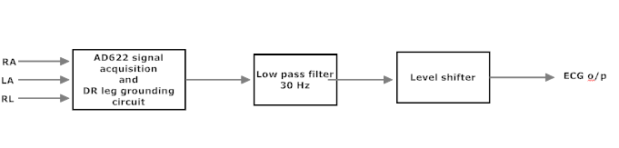

*Fig 3.3 Block diagram of ECG signal acquisition*

The level shifter is necessary to ensure that we do not feed a negative i/p voltage to the arduino. Thus level shifter is merely important to provide DC offset (here it provides a DC offset of 2.5V).

**CHAPTER-4**

ARDUINO COMPONENTS



The preceding chapters saw the development of hardware required for acquiring the ECG signal. To provide for communication between the smartphone and system for plotting the ECG signal, we use a microcontroller board. There were constraints on choosing the microcontroller as there were limited microcontrollers which could handle the capabilities required for communicating with the Internet of Things based application. After looking into the options available and considering the cost constraints associated with the product design, We ended up with an Arduino Duemilanove Microcontroller board.

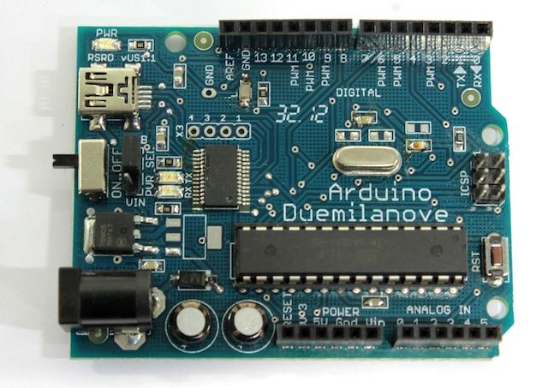

*Fig 4.1 Arduino Duemilanove At Mega 328 board[4]*

1. **ARDUINO DUEMILANOVE ATMEGA328**

The Arduino Duemilanove ("2009") is a microcontroller board based on the ATmega168 (datasheet) or ATmega328 (datasheet). It has 14 digital input/output pins (of which 6 can be used as PWM outputs), 6 analog inputs, a 16 MHz crystal oscillator, a USB connection, a power jack, an ICSP header, and a reset button. It contains everything needed to support the microcontroller; simply connect it to a computer with a USB cable or power it with a AC-to-DC adapter or battery to get started.

"Duemilanove" means 2009 in Italian and is named after the year of its release. The Duemilanove is the latest in a series of USB Arduino boards

**Summary of specifications:**

* Microcontroller : ATmega168
* Operating Voltage: 5V
* Input Voltage (recommended): 7-12V
* Input Voltage (limits): 6-20V
* Digital I/O Pins: 14 (of which 6 provide PWM output)
* Analog Input Pins: 6
* DC Current per I/O Pin: 40 mA
* DC Current for 3.3V Pin: 50 mA
* Flash Memory: 32 KB (ATmega328) of which 2 KB used by bootloader
* SRAM: 2 KB (ATmega328)
* EEPROM: 1 KB (ATmega328)
* Clock Speed: 16 MHz

**Powering the Arduino board**

The Arduino Duemilanove can be powered via the USB connection or with an external power supply. The power source is selected automatically. External (non-USB) power can come either from an AC-to-DC adapter (wall-wart) or battery. The adapter can be connected by plugging a 2.1mm centre-positive plug into the board's power jack. Leads from a battery can be inserted in the Gnd and Vin pin headers of the POWER connector. The board can operate on an external supply of 6 to 20 volts. If supplied with less than 7V, however, the 5V pin may supply less than five volts and the board may be unstable. If using more than 12V, the voltage regulator may overheat and damage the board. The recommended range is 7 to 12 volts.

The power pins are as follows:

VIN: The input voltage to the Arduino board when it's using an external power source (as opposed to 5 volts from the USB connection or other regulated power source). You can supply voltage through this pin, or, if supplying voltage via the power jack, access it through this pin.

5V: The regulated power supply used to power the microcontroller and other components on the board. This can come either from VIN via an on-board regulator, or be supplied by USB or another regulated 5V supply.

3V3: A 3.3 volt supply generated by the on-board FTDI chip. Maximum current draw is 50 mA.

GND: Ground pins.

**Memory Specifications**

The ATmega168 has 16 KB of flash memory for storing code (of which 2 KB is used for the bootloader); the ATmega328 has 32 KB, (also with 2 KB used for the bootloader). The ATmega168 has 1 KB of SRAM and 512 bytes of EEPROM (which can be read and written with the EEPROM library); the ATmega328 has 2 KB of SRAM and 1 KB of EEPROM.

**Input and Output**

Each of the 14 digital pins on the Duemilanove can be used as an input or output, using pinMode(), digitalWrite(), and digitalRead() functions. They operate at 5 volts. Each pin can provide or receive a maximum of 40 mA and has an internal pull-up resistor (disconnected by default) of 20-50 kOhms. In addition, some pins have specialized functions:

Serial: Pin 0 (RX) and Pin 1 (TX). Used to receive (RX) and transmit (TX) TTL serial data. These pins are connected to the corresponding pins of the FTDI USB-to-TTL Serial chip.

External Interrupts: Pins 2 and 3. These pins can be configured to trigger an interrupt on a low value, a rising or falling edge, or a change in value. See the attachInterrupt() function for details.

PWM: Pins 3, 5, 6, 9, 10, and 11. Provide 8-bit PWM output with the analogWrite() function.

SPI: Pin 10 (SS), Pin 11 (MOSI), Pin 12 (MISO), Pin 13 (SCK). These pins support SPI communication using the SPI library.

LED: Pin 13. There is a built-in LED connected to digital pin 13. When the pin is HIGH value, the LED is on, when the pin is LOW, it's off.

**Communication**

The Arduino Duemilanove has a number of facilities for communicating with a computer, another Arduino, or other microcontrollers. The ATmega168 and ATmega328 provide UART TTL (5V) serial communication, which is available on digital pins 0 (RX) and 1 (TX). An FTDI FT232RL on the board channels this serial communication over USB and the FTDI drivers (included with Windows version of the Arduino software) provide a virtual com port to software on the computer. The Arduino software includes a serial monitor which allows simple textual data to be sent to and from the Arduino board. The RX and TX LEDs on the board will flash when data is being transmitted via the FTDI chip and USB connection to the computer (but not for serial communication on pins 0 and 1).

1. **ADAFRUIT CC3000 WI-FI BREAKOUT BOARD**

The CC3000 Wi-Fi module is a small silver package which finally brings easy-to-use, affordable Wi-Fi functionality to your projects.

[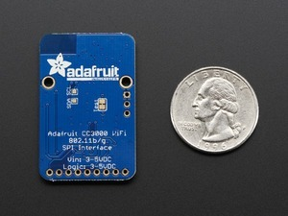](https://www.pololu.com/picture/view/0J5549)

*Fig 4.2 Adafruit Wi-Fi Breakout Board:Bottom view*

The Adafruit CC3000 WiFi breakout board (v1.1) is based on the CC3000 Wi-Fi module from TI. The onboard ceramic antenna, breadboard-compatible design, and the Adafruit CC3000 Arduino library (compatible with Arduino Micro, Leonardo, Uno, and Mega as well as our Arduino-compatible A-Star controllers) allow for easy integration into embedded projects. The CC3000 uses SPI for communication instead of UART, so the communication speed is not limited to a fixed baud rate. It supports 802.11b/g, open/WEP/WPA/WPA2 security, TKIP, and AES. A built-in TCP/IP stack with a BSD socket interface supports TCP and UDP in client and server mode with up to 4 concurrent socket connections. The board also has a tri-state buffer on the MISO pin to allow the use of the CC3000 with other SPI devices on the same bus. The CC3000 does not support "AP" mode, it can connect to an access point but it cannot be an access point by itself.

**Features**

* Uses SPI for communication
* Integrated 3.3 V regulator
* Integrated level shifter
* Tri-state buffer on the MISO pin
* Onboard ceramic antenna
* Two mounting holes
* Compact with 0.1″-pitch holes that are compatible with standard solderless breadboards and perfboards

[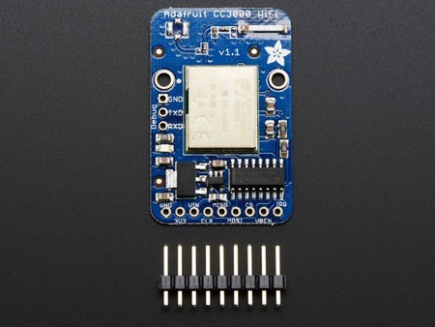](https://www.pololu.com/picture/view/0J5550)The board ships with all of its surface-mount parts populated. However, soldering is required for assembly of the included 0.1″ male headers.

|  |
| --- |
|  |
|  |

*Fig 4.3Adafruit CC3000 Wi-Fi breakout board: Top view*

1. **HC-05 Bluetooth Module**

HC-05 module is an easy to use Bluetooth SPP (Serial Port Protocol) module, designed for transparent wireless serial connection setup. Serial port Bluetooth module is fully qualified Bluetooth V2.0+EDR (Enhanced Data Rate) 3Mbps. Modulation with complete 2.4GHz radio transceiver and baseband. It uses CSR Bluecore04-External single chip Bluetooth system with CMOS technology and with AFH (Adaptive Frequency Hopping Feature). It has the footprint as small as 12.7mmx27mm. Hope it will simplify your overall design/development cycle.

**Specifications**

**Hardware features**

* Typical -80dBm sensitivity
* Up to +4dBm RF transmit power
* Low Power 1.8V Operation ,1.8 to 3.6V I/O
* PIO control
* UART interface with programmable baud rate
* With integrated antenna
* With edge connector
* Profiles: Bluetooth serial port
* Power supply: +3.3VDC 50mA
* Working temperature: -20 ~ +75Centigrade
* Dimension: 26.9mm x 13mm x 2.2 mm
* Frequency: 2.4GHz ISM band
* Emission power: ≤4dBm, Class 2
* Sensitivity: ≤-84dBm at 0.1% BER
* Speed: Asynchronous: 2.1Mbps(Max) / 160 kbps, Synchronous: 1Mbps/1Mbps

**Software features**

* Default Baud rate: 38400
* Data bits:8
* Stop bit:
* Parity:No parity
* Data control: Has supported baud rates 9600, 19200, 38400, 57600, 115200, 230400, 460800.
* If given a rising pulse in PIO0, device will be disconnected.
* Auto-connect to the last device on power as default.
* Permit pairing device to connect as default.
* Auto-pairing PINCODE:”0000” as default
* Auto-reconnect in 30 min when disconnected as a result of beyond the range of connection.
* Modulation: GFSK(Gaussian Frequency Shift Keying)
* Security: Authentication and encryption.4

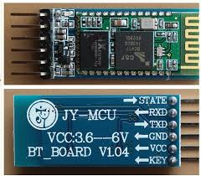

*Fig 4.5 HC-05 Bluetooth module*

**CHAPTER-5**

ANDROID-OPEN SOURCE OPERATING SYSTEM



**Android** is a mobile operating system (OS) based on the Linux kernel and currently developed by Google. Android was selected as the preferred development platform as it has the lowest entry level for developer enabling even beginners to start with. Each developer can download the Android SDK for free, without registration and install applications on Android driven devices. Furthermore, the connectivity between the Arduino board and the android smartphone to exchange data between the two can be implemented using Amarino toolkit.

Android is popular with technology companies which require a ready-made, low-cost and customizable operating system for high devices. Android's open nature has encouraged a large community of developers and enthusiasts to use the open-source code as a foundation for community-driven projects, which add new features for advanced users.

5.1 AMARINO SOFTWARE TOOLKIT

Normally smartphone events are tightly coupled to your phone device itself. When your cell phone is ringing, your phone speaker plays a ringtone. When you get a new text message, your phone displays it on its screen. Wouldn't it be thrilling to make thoses phone events visible somewhere else, on your wearable, in your living room, on your robot, in your office or where ever you want it to occur? Or would you like to use your smartphone sensors, like the accelerometer, light sensor, compass or your touchscreen to control other devices? Amarino is a toolkit, basically consisting of an Android application and an Arduino library which will help you to interface with your phone in a new dimension. You can build your own interfaces almost without any programming experience.

* Fig 5.1: Android talks to Arduino board via Bluetooth*

This toolkit is designed to work with smartphones based on the Android open source operating system. The good thing is, you don't need any programming knowledge in Android at all to get started with. You can start right away just by installing our provided Android application on your phone. It comes already with many preinstalled events you can select to send it over to your Arduino.

Amarino basically consists of three main parts (two mandatory and one optional):

Android application called "Amarino"

Arduino library called "MeetAndroid"

5.2 SENSORGRAPH

SensorGraph is a small example app demonstrating how to receive data from an Arduino by using Amarino's API. It reads sensor data from an analog input pin and sends the data to the phone. The phone displays the sensor data real-time on a nice graph. The SensorGraph example consists of an Arduino sketch and an Android project. Look thru the commented source code to learn how to use Amarino's API to receive data from Arduino.

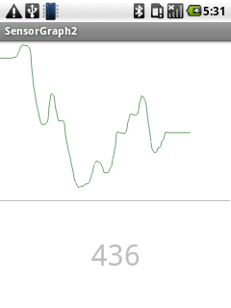

*FIG 5.2 SENSOGRAPH MOBILE APPLICATION*

While it is relatively simple to get the examples working, you will require some knowledge of android phones, android OS, soldering, Eclipse IDE or equivalent for modifying and packaging an android app, Arduino, Java programming language.

**CHAPTER-6**

INTERFACING OF THE SYSTEM



6.1 Arduino to computer

The Arduino Duemilanove board automatically draw power from either the USB connection to the computer or an external power supply. The power source is selected with a jumper, a small piece of plastic that fits onto two of the three pins between the USB and power jacks.

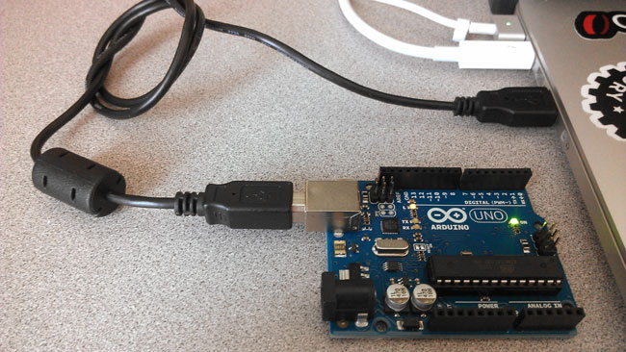

6.2 Arduino to Bluetooth

HC-05 module is an easy to use Bluetooth SPP (Serial Port Protocol) module, designed for transparent wireless serial connection setup

.The setup with Arduino board is as shown below using Rx and Tx pins of the board.

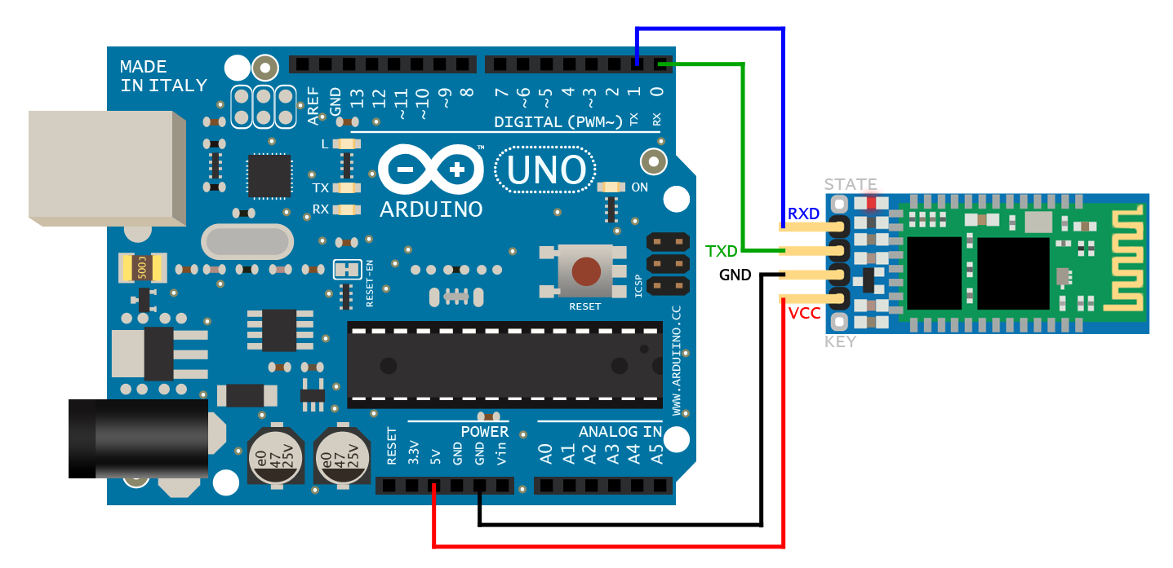 

6.3 Arduino to CC3000 wifi breakout board

The CC3000 hits that sweet spot of usability, price and capability. It uses SPI for communication (not UART!) so you can push data as fast as you want or as slow as you want. It has a proper interrupt system with IRQ pin so you can have asynchronous connections. It has an onboard 3.3V regulator that can handle the 350mA peak current, and a level shifter to allow 3 or 5V logic level. The antenna layout is identical to TI's suggested layout and we're using the same components, trace arrangement, and antenna so the board maintains its FCC emitter compliance. Even though it's got an onboard antenna we were pretty surprised at the range, as good as a smart-phone's.

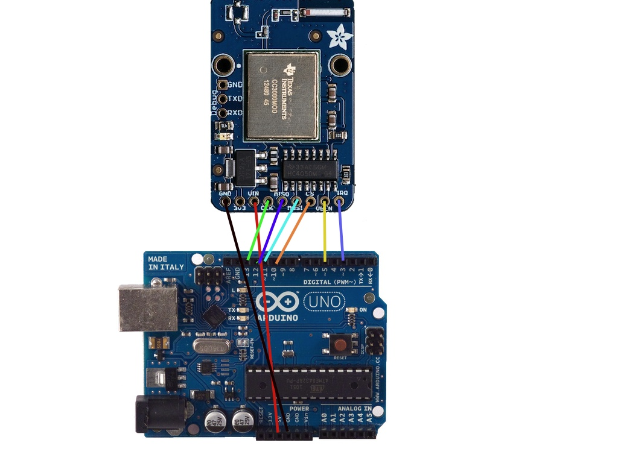

6.4 Complete interfacing block diagram 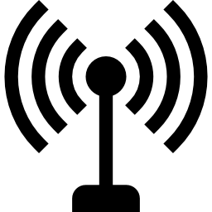 

Android Mobile Phone

HC-05 Bluetooth Module

Arduino board 1

Arduino board 2

ECG Sensing and Filtering Board

Power supply

 

Wi-Fi Router

CC3000 Wi-Fi Breakout board



Computer  
*(LAN or WIFI)

The front end hardware i.e. the ECG sensing and filtering circuit have their outputs in analog form. In order to process them and send it over the internet and Bluetooth we need to have them in digital format.

With the help of the ADC on Arduino, we will digitize each and every signal, process it if necessary and then with the help of serial Bluetooth module and CC3000 the signals will be transmitted wirelessly to a smart-phone and/or to a remote computer.

**CHAPTER-7**

SIMULATION



After completing the design of the project, we decided to check its results in real life situations in real time basis. Our project was tested on some individuals including group members, college students, etc.

7.1 ECG

A normal ECG machine has around 12 leads but in order to make our project portable and easy to use, we are using only 3 leads. The electrodes were connected to the right arm, left arm and left leg. As the heart beats each time, it generates eletrical pulses that generate electrical pulses that create electric potentials at various points in body.

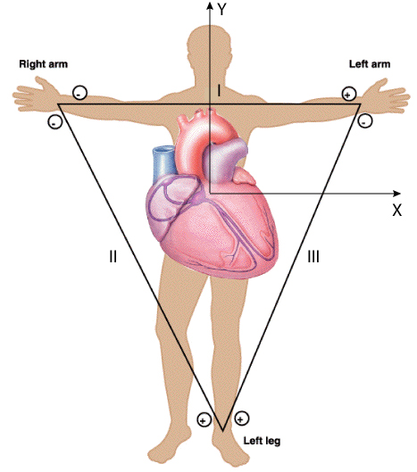

*FIG 7.1 THREE LEAD ECG*

7.2 Selection of ECG electrodes

The selection of electrodes is very important as these electrodes need to have proper connectivity with the body. Thus we chose silver chloride electrodes (AgCl), along with high impedance metallic electrodes which inhibit the flow of excess current.

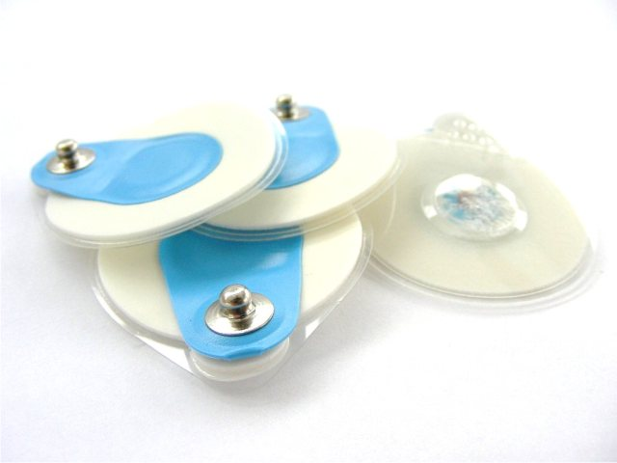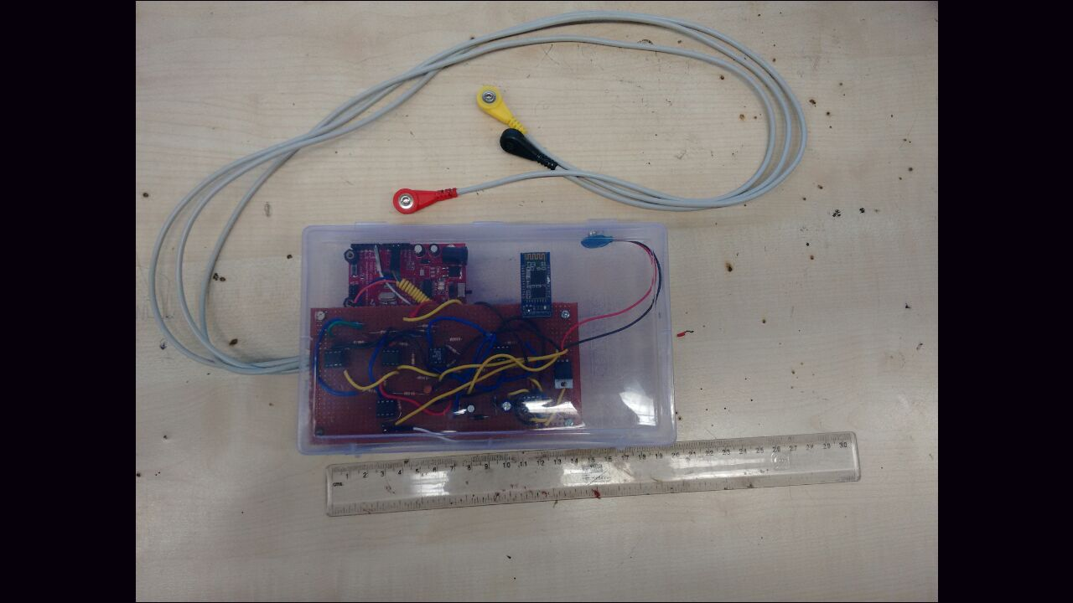

*FIG 7.2 AgCl ELECTRODES*

7.3 Observations

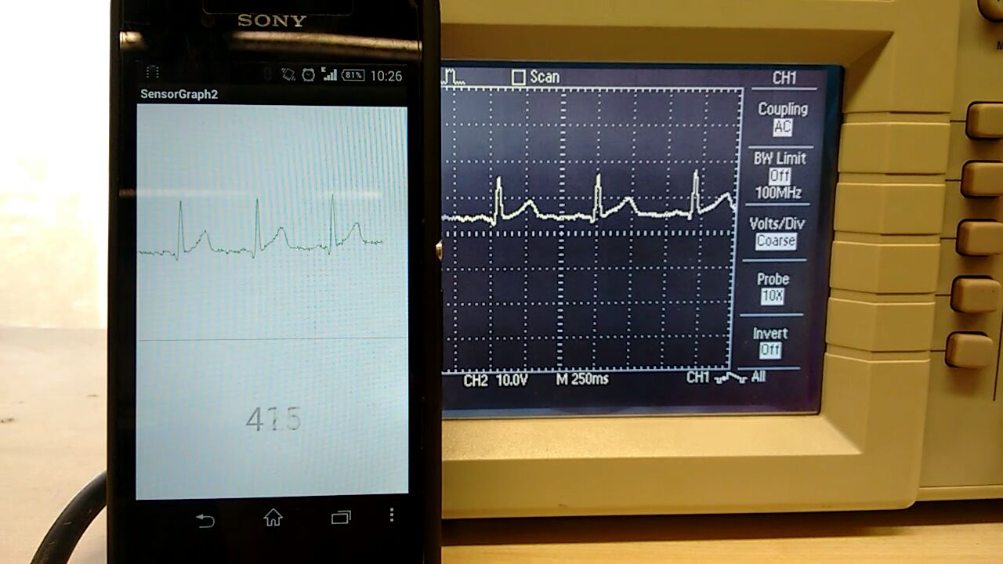

*FIG 7.3 SCREENSHOT OF ANDROID APP ALONG WITH SIGNAL ON OSCILLOSCOPE*

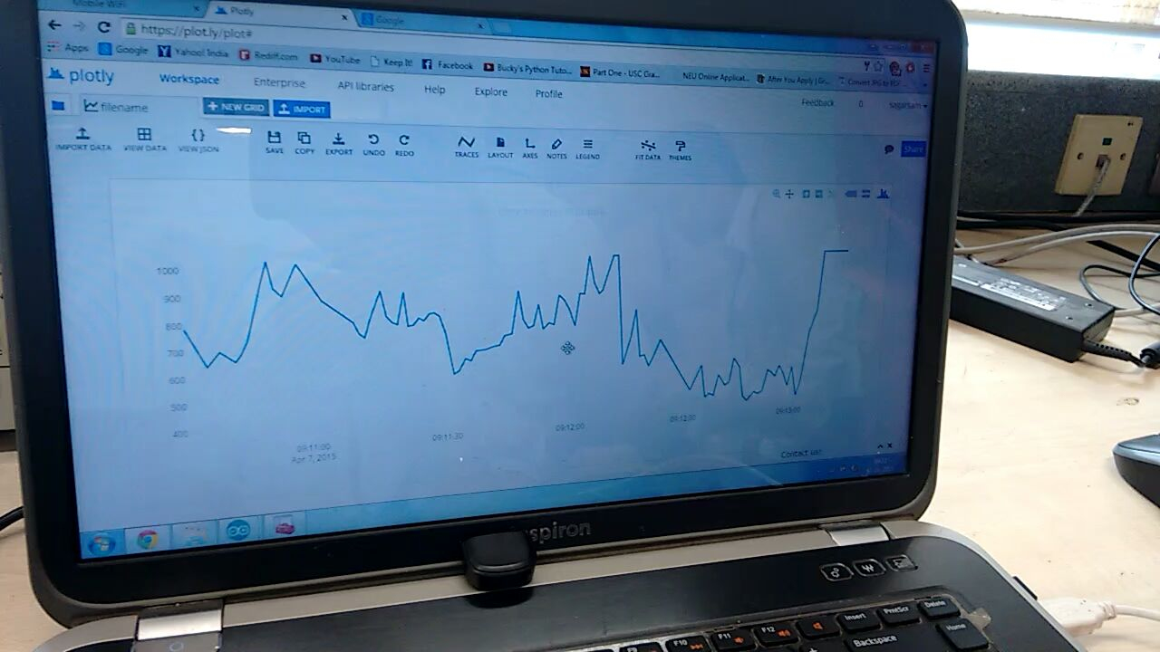

*FIG 7.4 REAL TIME ECG ON PLOTLY*

In order to get real time ECG on the Internet, we used a platform called plotly (https://**plot.ly**/) which is an online analytics and data visualization tool.  Plotly provides online graphing, analytics, and stats tools for individuals and collaboration. Doctors and medical practitioners over the world can view a patient’s ECG just by logging into his plotly account and accordingly view his real time ECG and diagnose his condition.

The doctor needs an account on plotly and an active internet connection to monitor the patient from any part of the world. But as can be seen from the above image, the ECG signal is not that accurate due to slow internet speed as well due to the limitations of the microcontroller to push data to the server on plotly. This can be lead to erroneous diagnosis hence work needs to be done in this part.

Upon comparing it with the standard ECG graph we understood that there are 4 chambers in our heart through which the blood flows giving a PQRST graph as shown below.

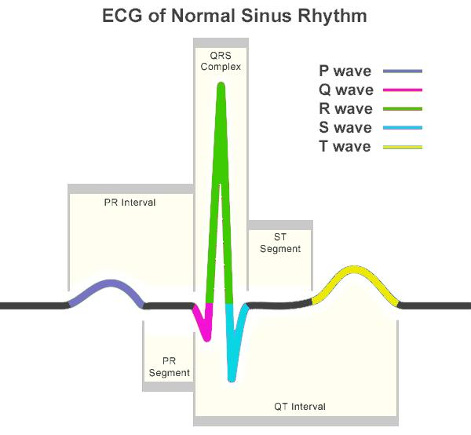

*FIG 7.5 SCHEMATIC REPRESENTATION OF NORMAL ECG WAVEFORM*

Waves Representation

P wave : Normal duration of less than or equal to 0.11 seconds. Shape is generally smooth. The atrial contractions are represented by the P wave and the voltage of signal wave is as low as1 mV. A clear P wave before the QRS complex denotes sinus rhythm. Absence of P waves denotes atrial fibrillation, junctional rhythm, and syno-atrial block. It is very difficult to analyze P waves with a high signal-to-noise ratio in ECG signal.

PR interval: Normally between 0.12 and 0.20 seconds.

QRS complex: Duration less than 0.12 seconds, amplitude greater than 0.5mV in atleast one standard lead. The largest deflection of voltage 10-20mV denotes the QRS complex which varies based on age and gender. It is a cardiac impulse traveling into the ventricular myocardium. Duration of the QRS complex denotes the time for the ventricles to depolarize and may provide information about conduction complications in the ventricles such as bundle branch block.

ST segment: Isoelectric, slanting upwards to the T wave in the normal ECG. It can be slightly elevated.

T wave : T wave deflection should be in the same direction as the QRS complex in atleast 5 of 6 limb leads. It is normally round and symmetrical. T wave denotes ventricular re-polarization. Large T waves may denote ischemia, and [Hyperkalemia](https://www.google.co.in/search?es_sm=93&q=Hyperkalemia&spell=1&sa=X&ei=Bq8uVa66IIL9ugSgn4CoBA&ved=0CBoQvwUoAA).

**CHAPTER-8**

APPLICATIONS AND ENHANCEMENTS



8.1 ADVANTAGES

1. Monitoring made simple .No complex coding required
2. Advanced technology means assured accuracy
3. Sleek. Simple .Always handy
4. Keep records
5. Cost effective as compared to present market models
6. Easy to use and access on android and plotly
7. The best feature is its portability and rugged design

8.2 DISADVANTAGES

1. Plotly is internet based thus internet connection required.
   1. APPLICATIONS
2. Used by physicians
3. Can be used at home by the user
4. Long distance and long term patient vitals monitoring.
   1. FUTURE SCOPE
5. Used in medical pods for part of full health diagnostic tool.
6. Addition of other non-invasive medical devices. Like glucometer, pulse meter, blood pressure measurement etc
7. Keep a database for future reference by doctors
8. Using mobiles data packets to send data over the internet.

**CHAPTER-9**

CONCLUSION



REFERENCES



* Microcontroller based heart rate monitor and arrythmia detector- Enyinnaya Egejuru- ECE445 senior design project Illinois institute of technology.
* Techniques for accurate ECG signal processing- Ajay Bharadwaj and Umanath Kamath
* Design and dimensioning of Active filters- www.beis.de
* http://www.daycounter.com/Circuits/OpAmp-Level-Shifter/OpAmp-Level-Shifter.phtml
* http://www.analog.com/media/en/technical-documentation/data-sheets/AD622.pdf
* http://www.ti.com/lit/ds/symlink/lm158-n.pdf
* DIY heart monitoring device-*Refik Hadzialic* available on www.radiolocman.com
* http://www.swharden.com/blog/2009-08-14-diy-ecg-machine-on-the-cheap/
* http://www.rcscomponents.kiev.ua/datasheets/hc_hc-05-user-instructions-bluetooth.pdf
* https://learn.adafruit.com/downloads/pdf/adafruit-cc3000-wifi.pdf
* https://plot.ly/arduino/dht22-temperature-tutorial/